DocShield
Mature MVP Product Requirements Document
Zero-content document passport, fingerprinting, embedded AI policy tags, signing history, and anomaly dashboard
Field | Definition
Product | DocShield
Version | Mature MVP PRD v1.0
Product model | Enterprise-hosted application + DocShield blind backend
Tier 1 | Fingerprinting with embedded AI policy tags
Tier 2 | Monitoring dashboard with anomaly detection
MVP posture | Pilot-ready, privacy-preserving, no raw document ingestion

Positioning: DocShield gives organizations a way to make PDFs verifiable, policy-aware, and trackable through controlled distribution without sending document content to DocShield.

1. Executive Summary
DocShield is a zero-content document passport platform for enterprises that need to prove document origin, attach machine-readable AI and sharing policies, maintain a multi-party signing history, and monitor controlled document distribution. The mature MVP is designed for enterprise pilots where the customer hosts the web application and local processing layer, while DocShield hosts a blind backend that stores only non-content metadata such as hashes, public keys, signed manifests, policy status, and access telemetry.
The product avoids automatic sensitive-data scanning. Customers decide the policy manually or through their own internal rules. DocShield provides the fingerprinting, signing, embedding, verification, and telemetry framework.
The mature MVP has two commercial tiers:
- Tier 1 - Fingerprinting + Embedded AI Tags: create a document fingerprint, attach a signed policy manifest, embed AI usage tags into the PDF, verify tamper status, and support layered signing history.
- Tier 2 - Dashboard + Anomaly Detection: add secure-link distribution, access telemetry, rules-based exposure scoring, abnormal download detection, geography summaries, and audit views.

2. Problem Statement
Enterprises exchange PDFs across vendors, customers, partners, and AI-enabled workflows, but once a file leaves the original system, three controls degrade quickly: provenance, policy enforcement, and visibility. Existing file-sharing and DLP tools can help inside a managed environment, but they do not provide a lightweight, machine-readable passport that travels with the document and can be verified by compatible tools.
The core problem is not that organizations cannot store documents securely; it is that recipients, downstream systems, and AI upload tools lack a simple way to answer four questions:
- Who issued this document?
- Has the document or policy manifest been changed since signing?
- Is this file allowed to be uploaded into external AI tools?
- Where has this document been accessed when shared through controlled links?

3. Product Goals and Non-Goals
Type | Item | Definition
Goal | Zero-content trust layer | Enable document trust without DocShield reading, storing, or processing raw document content.
Goal | Policy-aware documents | Attach machine-readable rules such as No External AI, Secure Link Only, No Forwarding, Public Sharing Blocked.
Goal | Layered signing history | Support multiple signatures over a document lifecycle: issuer, sender, recipient, approver, confirmer, and reissuer.
Goal | Controlled-share visibility | Provide access telemetry and anomaly signals when customers distribute documents through DocShield-compatible secure links.
Non-goal | Automatic PII detection | Not included. Customers choose the policy; DocShield does not scan document contents.
Non-goal | Universal tracking | Cannot reliably track raw PDFs everywhere after offline download, screenshot, print, or metadata stripping.
Non-goal | Dark web removal | Not included in MVP. Future leak identification can only work when a candidate file is available for extraction/verification.
Non-goal | Enterprise DLP replacement | DocShield complements DLP and file-sharing systems; it is not a full policy enforcement suite for every channel.

4. Target Users and Personas
Persona | Primary Need | MVP Outcome
Security / Risk Owner | Reduce uncontrolled AI upload and downstream document ambiguity. | Can define default policy templates and see verification/adoption metrics.
Business Document Issuer | Send a document with proof of origin and stated usage policy. | Can issue a protected PDF without understanding cryptography.
Recipient / Partner | Know whether a document is authentic and what policy applies. | Can verify issuer, tamper status, and signing history.
AI Gateway / App Developer | Decide whether a PDF may be uploaded into an AI workflow. | Can read embedded tags and call verification API.
Auditor / Compliance Reviewer | Reconstruct document history and access events. | Can export signing chain and access timeline.
DocShield Admin | Manage tenants, keys, SDK versions, and telemetry health. | Can operate the blind backend without seeing customer data.

5. Mature MVP Architecture
Architecture principle: customer-owned content stays inside the customer's environment. DocShield provides SDKs, manifests, verification services, key registry, telemetry ingestion, and dashboard services. The customer-hosted app and local processor handle raw PDFs and embedding operations.
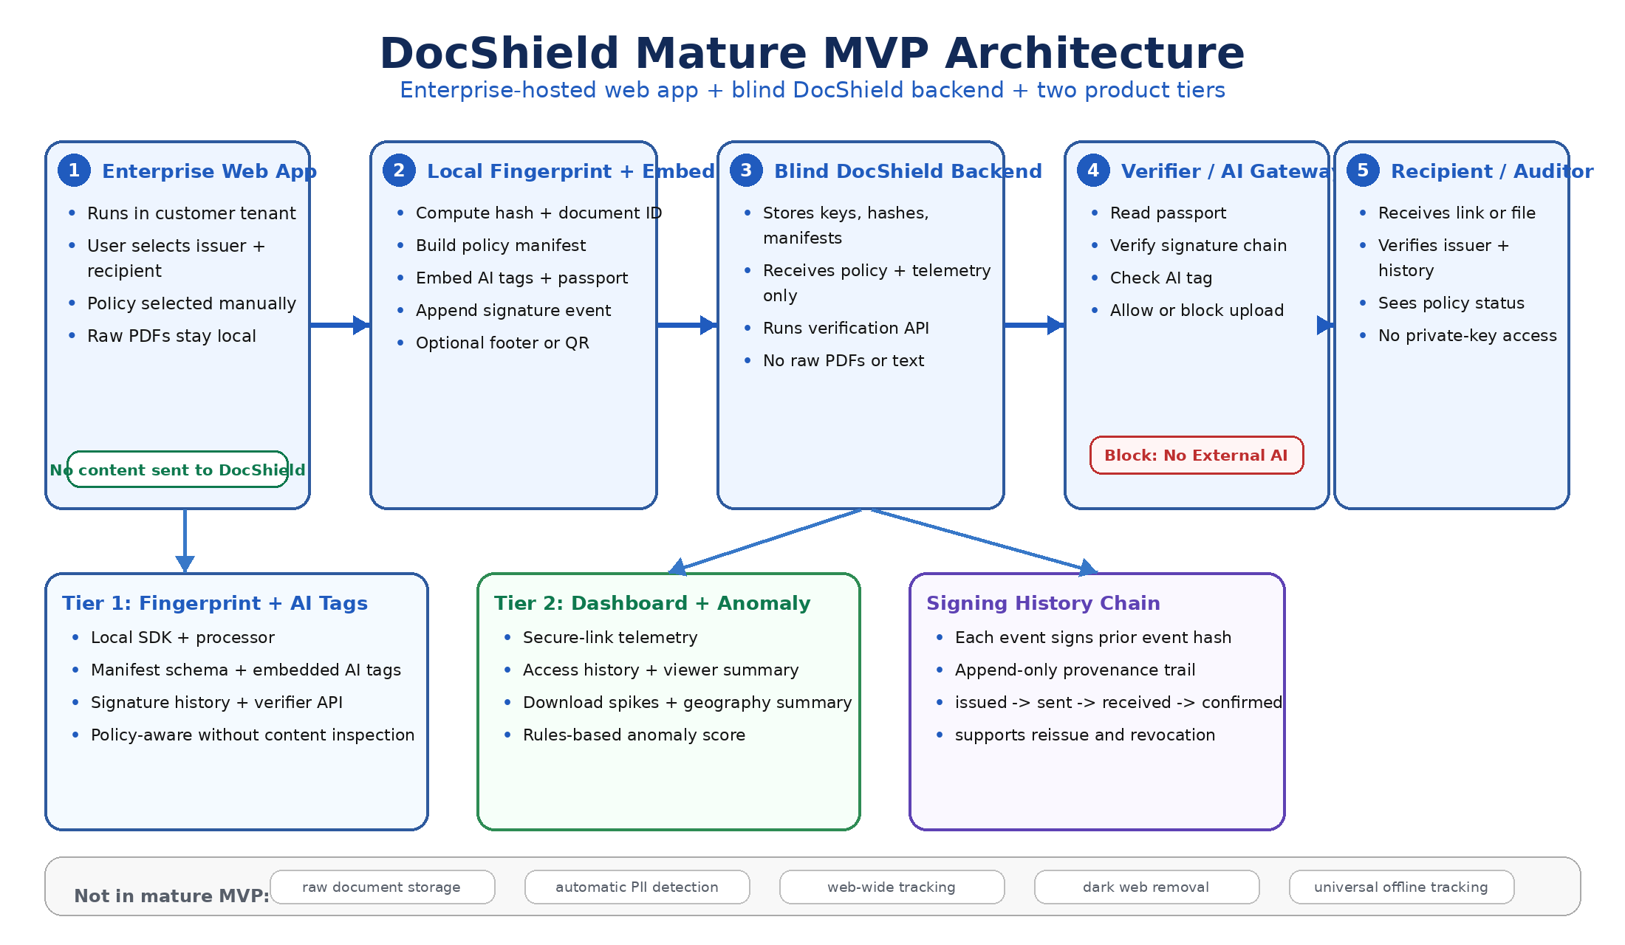
Figure 1. Mature MVP architecture: enterprise-hosted app, local fingerprinting/embedding, blind backend, verifier gateway, and tiered dashboard.

6. Deployment and Trust Model
Component | Hosted By | Sees Raw PDF? | MVP Responsibility
Enterprise Web App | Customer | Yes | User workflow, PDF upload, policy selection, local processing orchestration.
Local Processing Agent / SDK | Customer | Yes | Compute hash, create document ID, embed passport, append signing events.
DocShield Backend | DocShield | No | Tenant registry, public keys, signed manifest registry, verification endpoint, telemetry ingestion.
Secure Share Gateway | Customer or DocShield-managed dedicated tenant | Configurable | Issue links, enforce auth/token checks, serve protected files, emit access events.
Verifier / AI Gateway | Customer, partner, or AI app | Only uploaded file at point of use | Read passport, verify signatures, enforce AI policy tag.
Dashboard | DocShield | No raw content | Display access events, document metadata, policy state, risk signals, audit trails.

7. Product Tiers
Tier | Name | Included Capabilities | Buyer Value
Tier 1 | Fingerprinting + Embedded AI Tags | Local fingerprinting SDK; document passport schema; AI policy tags; PDF metadata embedding; optional visible footer/QR; signature chain; verification API; sample AI upload gateway. | Makes documents verifiable and policy-aware without content scanning.
Tier 2 | Dashboard + Anomaly Detection | Secure-link telemetry; access logs; viewer/IP summary; geography summary; download spike detection; rules-based anomaly score; alert queue; audit export. | Adds visibility into controlled distribution and abnormal sharing patterns.

8. End-to-End User Flow
- Tenant administrator installs the DocShield local processing package and configures tenant identity, issuer keys, policy templates, and allowed verifier endpoints.
- Issuer opens the customer-hosted DocShield web app and uploads a PDF. The file remains inside the customer's environment.
- Issuer enters recipient and chooses a policy template such as No External AI, Secure Link Only, No Forwarding, or Public Sharing Blocked.
- Local processor computes a fingerprint, creates a document ID, builds a policy manifest, signs it, and embeds the passport into the PDF metadata plus optional visible footer/QR.
- If the document is sent through secure-link mode, the share gateway issues a unique link and logs access events without exposing document contents to the blind backend.
- When a compatible AI gateway or verifier receives the PDF, it reads the embedded passport, verifies the signature chain, checks the AI policy tag, and allows or blocks the upload.
- Tier 2 dashboard aggregates telemetry and displays document history, access timeline, unusual download patterns, and anomaly score.

9. Core Data Objects
DocShield stores only non-content records. The following objects define the mature MVP data model.
Object | Purpose | Representative Fields
Tenant | Organization boundary and configuration. | tenant_id, org_name, domain, policy_templates, key_ids, admin_users
Document Manifest | Signed passport attached to a document. | schema_version, document_id, tenant_id, fingerprint, policy, created_at, issuer_key_id
Embedded AI Tags | Machine-readable policy fields used by AI gateways. | external_ai_upload, training_allowed, summarization_allowed, retention_allowed, secure_link_required
Signature History Entry | Append-only lifecycle event. | event_id, action, actor_org, actor_key_id, timestamp, previous_event_hash, signature
Access Event | Telemetry from secure-link distribution. | event_id, document_id, link_id, timestamp, IP hash, user agent hash, country, action
Risk Signal | Derived anomaly finding. | document_id, score, reason_codes, generated_at, severity

10. Manifest and Signing History Example
{
"schema_version": "1.0",
"tenant_id": "tenant_acme",
"document_id": "doc_7f92ab31",
"content_fingerprint": "sha256:<computed-inside-tenant>",
"policy": {
"external_ai_upload": "blocked",
"secure_link_required": true,
"forwarding": "blocked",
"public_sharing": "blocked"
},
"embedded_ai_tags": [
"NO_EXTERNAL_AI",
"SECURE_LINK_ONLY"
],
"history": [
{
"event": "issued",
"actor_org": "SupplierCo",
"timestamp": "2026-06-20T18:30:00Z",
"signature": "ed25519:<signature>"
},
{
"event": "confirmed_received",
"actor_org": "BuyerCo",
"previous_event_hash": "sha256:<prior-event>",
"timestamp": "2026-06-20T19:10:00Z",
"signature": "ed25519:<signature>"
}
]
}

11. Functional Requirements
ID | Capability | Priority | Requirement
FR-01 | Tenant setup | P0 | Admin can register tenant, configure domains, policy templates, issuer identities, and public keys.
FR-02 | Local SDK | P0 | SDK computes hashes, creates document IDs, embeds passports, and appends signing history without sending content to DocShield.
FR-03 | Policy manifest | P0 | Manifest supports issuer, recipient, policy tags, fingerprint, timestamps, schema version, and signature references.
FR-04 | Embedded AI tags | P0 | PDF contains machine-readable tags for No External AI and other policy decisions.
FR-05 | Signature history | P0 | System supports multiple signed lifecycle events with previous-event hash chaining.
FR-06 | Verification API | P0 | Verifier can validate signature chain, tenant key status, policy state, and tamper status using document passport metadata.
FR-07 | AI upload gateway sample | P0 | Reference upload page blocks files tagged No External AI and explains the reason.
FR-08 | Secure link issuance | P1 | Issuer can create recipient-specific secure links with token checks and expiration.
FR-09 | Access telemetry | P1 | System logs open/download events, hashed IP/user-agent, timestamp, action, and derived geography.
FR-10 | Anomaly scoring | P1 | Dashboard flags high download volume, new geography, repeated failures, unusual time, or multiple viewer clusters.
FR-11 | Audit export | P1 | Admin can export manifest, signing history, verification status, and access event timeline.
FR-12 | Revocation | P1 | Admin can revoke a document or signing key; verifiers show revoked status on future checks.
FR-13 | Role-based access | P1 | Admin, issuer, auditor, and viewer roles have distinct access permissions.
FR-14 | API keys and webhooks | P2 | Integrations can receive verification results, access events, and risk alerts.

12. Non-Functional Requirements
Category | Requirement
Privacy | DocShield backend must never receive raw PDFs, OCR output, extracted text, or document previews. Content fingerprint is computed inside customer environment.
Security | All backend APIs require OAuth2/client credentials or signed requests. Sensitive metadata is encrypted at rest. Key rotation is supported.
Availability | Verification API target availability for pilot: 99.5%. Local verifier should degrade gracefully using cached public keys when backend is unavailable.
Performance | Local processing target: protect a typical 10-page PDF in under 5 seconds. Verification target: under 500 ms backend round-trip excluding upload time.
Scalability | MVP target: 10 tenants, 100K document manifests, 1M access events.
Auditability | All administrative actions, key changes, policy changes, revocations, and verification decisions must be logged.
Interoperability | Manifest format should be JSON with stable schema versioning and a documented verifier contract.

13. Anomaly Detection Rules for Mature MVP
The MVP should use transparent, rules-based risk scoring. Do not position it as heavy ML. The score should explain its reasons.
Signal | Rule | Severity Contribution
Download spike | Downloads exceed tenant-defined threshold within a rolling time window. | Medium to High
New geography | Document accessed from a country not previously observed for the recipient or tenant. | Medium
Multiple viewer clusters | Same link accessed from several IP/user-agent clusters. | Medium
Repeated failed token checks | Several invalid token attempts against the same document/link. | Medium
Revoked document access | Access attempt after document or key revocation. | High
Policy conflict | Verifier sees No External AI tag but upload attempt continues or override is requested. | High

14. MVP Acceptance Criteria
Area | Acceptance Criteria
Zero-content guarantee | A demo can show that raw PDFs remain in customer-hosted storage and only hashes/manifests/telemetry reach DocShield.
Document protection | User can upload a PDF inside enterprise app, choose policy, generate protected PDF, and download/share it.
Embedded policy | Protected PDF contains readable policy manifest and AI tags that the verifier can extract.
Verification | Verifier confirms issuer, signature validity, policy state, signing history, and revocation status.
AI upload control | Reference AI upload gateway blocks No External AI documents and allows policy-compliant documents.
Signing history | Two or more parties can append signed events and the verifier can show the event chain.
Dashboard | Tier 2 dashboard displays access events, risk score, alert reasons, and audit export.
No impossible claims | Pitch and UI do not claim universal offline tracking, automatic PII detection, dark web removal, or unremovable watermarking.

15. Pilot Demo Scenario
Scenario: SupplierCo sends an invoice PDF to BuyerCo. SupplierCo signs it, BuyerCo confirms receipt, and the document blocks external AI upload. The secure-link dashboard first shows normal access, then flags simulated abnormal downloads from multiple geographies.
1. Protect invoice PDF inside customer-hosted app.
2. Apply policy: No External AI + Secure Link Only.
3. Append SupplierCo issued signature.
4. Append BuyerCo confirmed receipt signature.
5. Upload to AI gateway; gateway blocks with reason.
6. Open through secure link; log events.
7. Simulate abnormal traffic; dashboard raises anomaly alert.

16. Metrics and Success Criteria
Metric | MVP Target
Content privacy | 0 raw documents, extracted text, or OCR payloads stored by DocShield backend.
Verification success | 95%+ protected PDFs verify correctly across supported PDF viewers and upload flows.
Policy enforcement | 95%+ No External AI documents blocked in the reference gateway.
Pilot adoption | 3 pilot organizations can issue at least 25 protected documents each.
Dashboard value | Security/admin users can explain top risk reasons without engineering support.
Time to protect | Median protect workflow under 60 seconds for a business user.

17. Risks and Mitigations
Risk | Impact | Mitigation
Metadata stripping | Embedded passport may be removed by some tools. | Use layered embedding: metadata, optional footer/QR, sidecar manifest for controlled channels. Be clear that stripped files lose verifiability.
False sense of control | Users may assume tracking works after offline redistribution. | UI language must distinguish controlled-link telemetry from universal tracking.
Key management complexity | Pilot customers may struggle with signing keys. | Offer simple local key package for MVP and enterprise KMS integration later.
AI app adoption | Third-party AI tools may not support DocShield tags. | Provide reference gateway, browser extension prototype, and API spec for integrators.
PDF compatibility | PDFs vary by producer and may break metadata embedding. | Support a defined PDF compatibility matrix and fallback to sidecar manifest.

18. Release Plan
Phase | Duration | Output
Phase 1: Core SDK and manifest | Week 1-2 | Fingerprinting, manifest schema, signing, local embed, verify extraction.
Phase 2: Enterprise web workflow | Week 3 | Customer-hosted upload, policy selection, protected PDF generation, issuer templates.
Phase 3: Verifier and AI gateway | Week 4 | Reference verifier, upload blocker, revocation check, policy explanation.
Phase 4: Signing history | Week 4-5 | Multi-party event append, chain validation, history viewer.
Phase 5: Dashboard and anomaly | Week 5 | Access telemetry ingestion, dashboard, rules-based risk scoring, alerts.
Phase 6: Pilot hardening | Week 6 | Security review, compatibility testing, audit export, demo polish, documentation.

19. Open Questions
- Should the mature MVP support only PDF, or include Office documents through sidecar manifests?
- Should the secure share gateway be purely customer-hosted, DocShield-hosted per-tenant, or both?
- Which AI policy tags should be mandatory in v1: No External AI, No Training, No Retention, No Summarization, or Secure Link Only?
- Should signing keys be generated locally by the customer or issued through a DocShield-managed tenant key service?
- Should recipient identity be embedded directly, tokenized, or stored only in the customer's environment?

20. Mature MVP Positioning
One-sentence pitch: DocShield is a zero-content document passport that lets enterprises fingerprint PDFs, embed AI usage rules, maintain multi-party signing history, and monitor controlled sharing without exposing document contents to DocShield. Boundary: no universal tracking, automatic PII scanning, or dark web removal.

